COMMENTS OF CONSUMER-OWNED UTILITIES REGARDING BPA’S PRELIMINARY AVERAGE SYSTEM COSTS METHODOLOGY

Submitted: January 21, 2026

PPC, NRU, WPAG and PNGC (hereafter referred to as the “the COUs”) provide the following comments in response to the Preliminary Draft ASCM released by BPA on December 10.

The following comments are preliminary and may be updated, revised, or completely amended during the formal comment period. By not raising a specific issue(s) in these comments, COUs do not waive the right of all COUs and COU groups or any individual COU or COU group to comment on such issue(s) in the future.

ASC Review Process

To enhance transparency and ensure stakeholder engagement, BPA should incorporate into its ASC review procedures a requirement that each review process begin with a publicly noticed workshop (such as via tech forum) held at least two weeks before the review process formally begins. This workshop could be modeled on the workshop held prior to the BP-26 ASC review but should be publicly noticed rather than invitation-only.

BPA should post all workshop materials online at least two days in advance, and ensure that each workshop is included on BPA’s public events calendar. Establishing this consistent, open kickoff step will provide stakeholders with early and reliable notice of BPA’s planned approach for the cycle and support informed participation throughout the ASC review process.

This transparency is especially important because the start date of the ASC review process is not fixed and may change from cycle to cycle. A publicly noticed kickoff workshop would help ensure that all interested parties are aware of when and how the process is beginning.

Energy Storage Devices

We appreciate BPA’s concern that the future is largely unknown as to the ultimate application and related impact of Energy Storage Devices. As has been discussed, these devices are diverse in terms of size, duration, ramping capability, topographical location, functional application and many other aspects which will produce a wide-ranging result within Production, Transmission, and Distribution functions. Furthermore, these devices can be high cost and have significant impacts on the ASC calculations.

While we do not yet have a position on BPA’s proposal to leverage the PTD ratio, we are concerned that reliance on this ratio may not always result in a balanced or representative allocation of Energy Storage Device costs, particularly where such resources are developed to address Transmission and/or Distribution needs. In those circumstances, it may be appropriate for BPA to consider alternative ratios that better align cost allocation with the underlying drivers of the investment, without presuming a consistently high allocation to any single functional category.

New Large Single Loads

In the 2008 ASCM, BPA adopted an approach to the requirements of §5(c)(7)(a) that allowed participating utilities to allocate specific long-term resource costs to NLSL loads. This allocation is important because those costs and loads are statutorily required to be excluded from the ASC calculation. Notably, without §5(b) Power Sales Contracts, IOUs don’t undergo formal resource dedication. Unless an NLSL is served with NR power, no specific IOU resources are dedicated through contract to NLSL load. Therefore, in practice, the 2008 ASCM gave IOUs discretion to structure their resource dedication within the Appendix 1 spreadsheet.

In the draft ASCM it became clear that IOUs could choose to dedicate lower cost resources to NLSLs to reduce their ASC, responding to this concern BPA added the NLSL exception to the final ASCM. The NLSL exception disallowed removal of NLSL load and resource costs to increase a utility’s ASC. In BP-26, 5 of the 6 IOU’s triggered the NLSL exception. By doing so, IOUs ensured that the implementation of §5(c)(7)(a) would not reduce their ASC.

For this reason, the COU’s are not opposed to BPA’s proposed approach in §301.4.p of the preliminary draft ASCM. Using a utility’s Base Period ASC for pre-2026 ASCM NLSLs effectively captures the de facto outcome of the previous approach while simplifying implementation. Additionally, using the average cost of new resources for post-2026 ASCM NLSLs will fairly allocate the new resources costs to new loads.

Distribution Losses

We are supportive of BPA requiring the use of a single method to calculate measured distribution losses. In the 2008 ASCM, BPA created a methodological hierarchy based on whether utilities had: 1) recently completed a distribution loss study, or, 2) had sufficient revenue grade meters to measure distribution losses directly. Utilities with neither used the Default method, calculating total system losses using 5 years of FERC Form 1 ‘source’ and ‘disposition’ data. In BP-26, the region’s 6 IOUs used at least 2 of the 3 methodological approaches allowed under the 2008 ASCM. This approach allowed utilities to undergo studies or meter upgrades with the outcome being a material change to their measured distribution loss factor. Using a single approach in the 2026 ASCM is a sure-fire way to avoid cherry-picking. However, without more information, we are unable to affirmatively support BPA’s proposed methodology as preferable to alternatives.

Transmission

We are supportive of BPA’s proposal to remove all transmission costs from the ASC except for those which are in principle as near to the transmission costs included in the PF rate as possible. However, there are outstanding questions as to whether BPA’s ASCM proposal implements the “like for like” principle fairly, how differences between the approaches can be mitigated over time, and whether the transmission costs IOUs are including in their filings are transparent and verifiable.
First, functionalizing all of Account 565 “Transmission of Electricity by Others (Wheeling)” to Production expands upon BPA’s proposed “like for like” treatment by including all legs for all resources and use cases. For preference customers, BPA’s POC contract only embeds the cost of the last leg of transfer service for non-federal resources serving net requirements load in wholesale power rates. BPA’s ASCM should likewise only include the last leg of transmission wheeling.

Second, Account 447 is the FERC account where IOU’s account for the credits they receive from wholesale power sales to other utilities. The FERC Uniform System of Accounts describes it as follows:

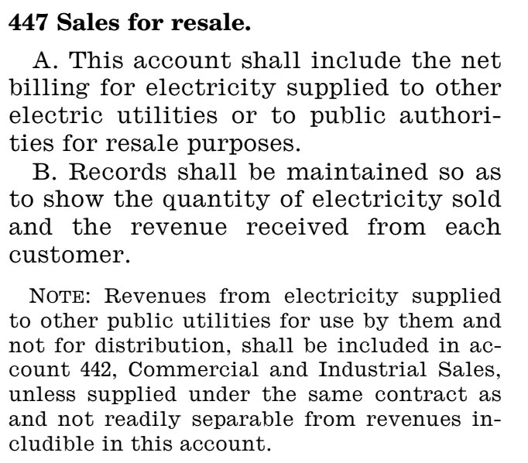

Unfortunately, we understand that IOUs book considerable transmission costs in this account as well; and because the income from these power sales far outstrips the transmission costs associated with their delivery, Account 447 appears in utilities FERC Form 1 as a large credit. BPA proposes to include this entire account in IOU’s ASCs despite COU’s having no transparency into the magnitude of these costs.

By contrast, where IOUs book additional market-related transmission costs elsewhere, the preliminary draft requires those costs to be separately identified and supported through documentation. COUs request that IOUs be required to provide comparable documentation for any transmission-related costs embedded in Account 447, as this transparency is necessary to determine whether BPA’s proposed “like-for-like” transmission treatment is being applied consistently and without inflating IOU ASCs

ASC Consultation

The COUs oppose BPA’s proposed rewrite section 301.6. to exclude customer groups – COUs and IOUs – from initiating a 5(c)(7) consultation process. The COUs strongly recommend that BPA maintain the language from the 2008 ASCM. Given that BPA will, at most, have a single 16 aMW DSI customer during Post-2028 REP we offer no opinion on BPA’s proposed removal of the DSI customer group. Furthermore, and acknowledging that Port Townsend and current/future NLSL’s may have their own perspectives, we generally believe that REP payers regardless of customer class would have similar incentives around consultation reinitiation.

Variance Analysis

Utility regulators commonly use variance analysis to flag individual FERC accounts that meaningfully deviate from past years for further review. Requiring variance analysis on all Appendix 1 inputs will similarly support BPA’s ASC development. In the October 24 draft of BPA’s ASC Rules of Procedure, §2.1.1.1(d) obligates participating utilities to incorporate variance analysis into their Base Period ASC Filing. We are encouraged by this explicit language; however, a broader set of years is necessary to provide the requisite scrutiny. The COU’s contend that it would be prudent to analyze the four years immediately preceding the Base Case year. Therefore, BPA should amend §2.1.1.1(d) to require utility’s ASC filings to include the Appendix 1 inputs for both the two prior Base Period ASC Filings and the two prior Informational ASC Fillings. For each Appendix 1 input, the Base Period ASC filling should establish variance between the current filing year and each of the four previous years as well as between the current filing year and the four-year historical average. Furthermore, BPA should overtly reserve the right in the ASC Rules of Procedure to normalize Appendix 1 inputs if the utility cannot provide adequate justification for major deviations.

Injuries and Damages (Account 925)

We understand BPA’s proposal as allocating these costs initially to distribution – pending commission approval. Injuries and Damages costs could be included in the ASC calculations to the extent they are approved for recovery in retail rates by relevant Commissions, through a separate Table 1 line item. These commission approved costs would then be functionalized according to the Labor Ratio. To prevent double recovery, these costs would not be allowed to be recovered from the Regulatory Assets or Liabilities accounts.

At this time, we tentatively see this as an improvement over a direct assignment from FERC Form 1, particularly for lower cost items. However, we remain concerned that wildfire-cost risk exposure from the IOUs distribution and transmission systems could result in significant wildfire-related costs being allocated to production under BPA’s ASCM proposal. We recommend that BPA exclude all wildfire related costs from production for purposes of the ASCM on the basis that such costs are (i) likely to arise from the exchanging utility’s transmission and distribution business lines and (ii) akin to costs arising from “uncontrollable events” that would be excluded from the §7(b)(2) rate test. With respect to the latter, this would be place the ASCM and the §7(b)(2) on a more apples to apples basis.

Exclusion of Disallowed Costs

To protect customers, IOUs rate making requires robust regulatory review which routinely disallows costs from being borne by utility ratepayers. In the REP, each IOUs ASC will be developed using Appendix 1 inputs which rely on FERC Form 1 data. FERC Form 1 is a financial accounting record, not a ratemaking document. It can, and will, include disallowed costs. Costs included in FERC accounts that are disallowed by the IOU’s regulatory commission(s) for retail ratemaking must be identified (nature and amount) and removed for ASC purposes. This will better align utility ASC filings with retail ratemaking. If the utility’s ASC FERC accounting period doesn’t match the test period used by the regulatory commission for IOU retail ratemaking, such like disallowed costs should be identified and removed from specific accounts in the utility’s ASC filings if applicable.

To ensure IOU compliance with the recommended cost exclusions, BPA should amend Attachment A “Senior Financial Officer Attestation” to read:

2. The Base Period ASC Filing excludes the costs associated with: (a) the cost of additional resources in an amount sufficient to serve any New Large Single Load (NLSL) after September 1, 1979; (b) the cost of additional resources in an amount sufficient to meet any additional load outside the region occurring after December 5, 1980; (c) the costs of any generating facility which is terminated prior to initial commercial operation; and (d) any costs or like costs reported in a utilities FERC Form 1 filing that were disallowed by any Regulatory Body(ies) with jurisdiction to approve retail or wholesale rates in the region.

The COUs offer this solution to align ASC development with the intent of the Northwest Power Act. In the legislative history, the express purpose of the REP – subject to statutory limitations – is to reduce retail rate disparity between residential and small farm customers regionwide. To the extent Regulatory Body(ies) direct costs to be borne by shareholders as opposed to rate payers – by disallowing costs – there is no reason REP payers should subsidize costs that have been excluded from retail rates. The prospect of unrecoverable costs decreasing earnings is part of the regulatory risk equity investors readily accept in exchange for higher expected returns. If IOUs are allowed to include their equity inflated weighted cost of capital (WCC) in ASC development, then regulatory orders providing the counterbalance actually experienced by IOU ratepayers should likewise be fully incorporated.

Moreover, the COUs believe that BPA’s proposed escalation codes gross up IOUs’ ASCs, on a forecast basis, similarly to the ‘pro forma’ adjustments that are frequently ordered by regulatory commissions. If disallowed costs – the primary downward adjustment – are not identified and excluded in developing ASCs, then the analysis will only capture the upward adjustments omitting the actions regulators take to protect ratepayers.

The WUTC and OPUC have annual “Commission Basis” reporting requirement for the purpose of tracking electric utility actual “Commission Basis” results of operations after each FERC accounting year. These annual reporting requirements are to reflect the utility’s actual results of operations adjusted for Commission ordered disallowances. These reporting requirements should be leveraged and will not require BPA to return to the burdensome jurisdictional approach.

Return on Equity

If BPA does not exclude disallowed costs from IOU ASCs as suggested above, then BPA should reexamine the rate of return allowed on the IOU capital structure to align returns with regulatory risk. BPA could easily effectuate this change by removing §301.4.o.1-3 from the ASCM and adding language similar to footnote d/ of the 1984 ASCM.

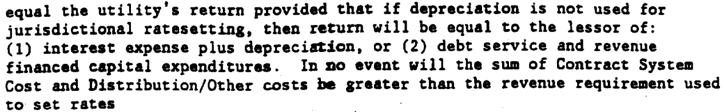

The COU’s appreciate your consideration of these comments.

Consistent with the requirements of WAC 480-100-257 and WAC 480-07-510 for WUTC regulated utilities, OAR 860-027-0070 for OPUC regulated utilities, or analogous requirements in other regulatory jurisdictions.
House Report (Interior) at 35

